NAME: FARHATH RUMAANA H

ROLL NO: CH.EN.U4CCE22010

Compile-time Polymorphism (Method Overloading)

Program:

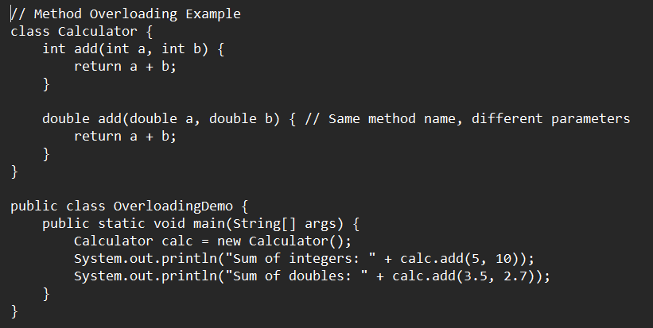

Output:

Runtime Polymorphism (Method Overriding)

Program:

Output:

Abstraction

Program:

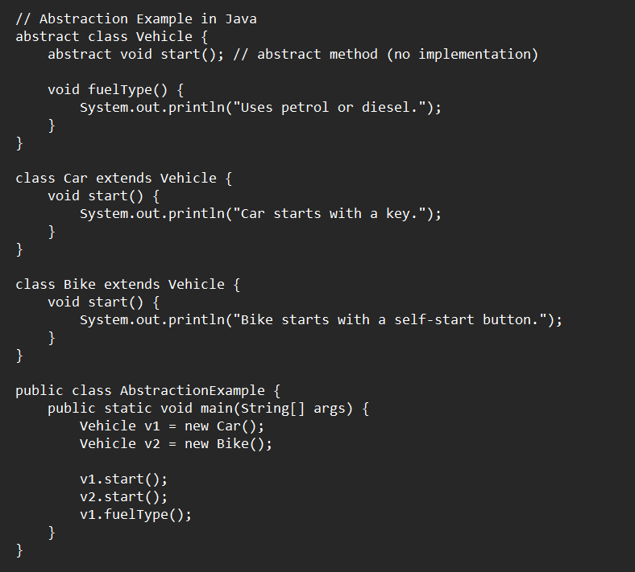

Output:

Encapsulation

Program:

Output:

